**OWASP API Top 10 (2023) - Detailed Explanation with issue and practical**

**Vulnerable Target – crAPI**

**API 01:2023 — Broken Object Level Authorization (BOLA)**

**🔍 Issue:**

APIs expose object IDs in requests.

Attackers modify object IDs to access unauthorized resources**.**

**🔨 Exploitation :**

First logging in the application and intercept the location end point

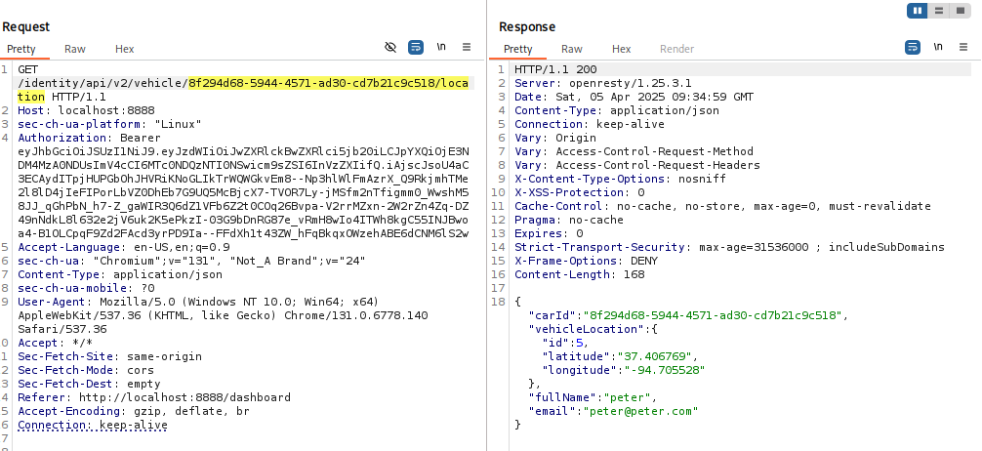

**And go to the community section for test bola and intercept this request and I copied vehicle id**

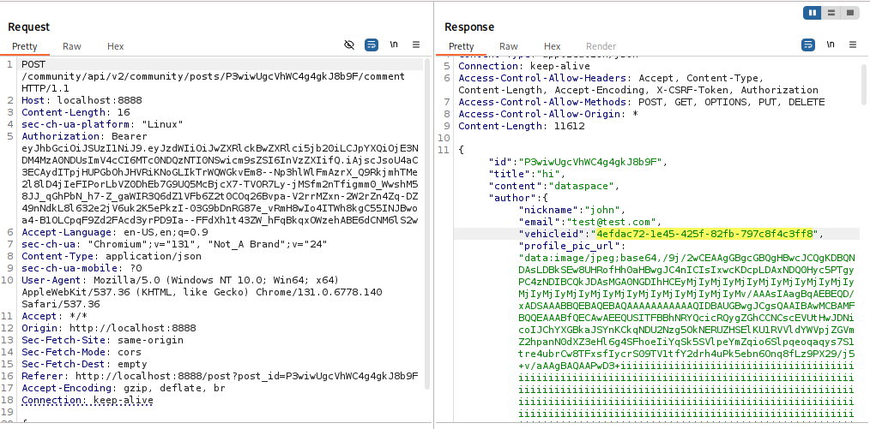

**And copied vehicle id change with real vehicle id and leak the information(location) of other user you can see this here this is confirm to bola**

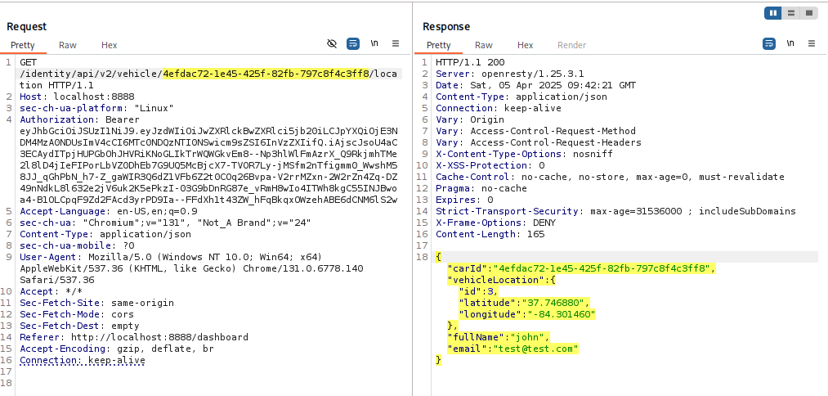

**🛑 API 02:2023 —** Broken Authentication

**🔍 Issue:**

Weak authentication allows attackers to bypass login.

Issues include default passwords, no rate limiting, or JWT token flaws**.**

Click on forget password

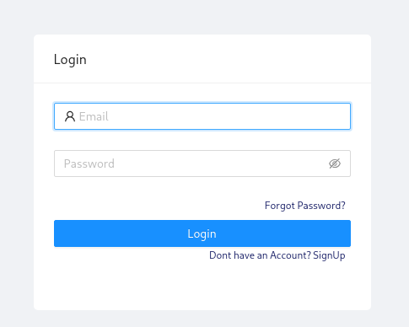

Enter the email

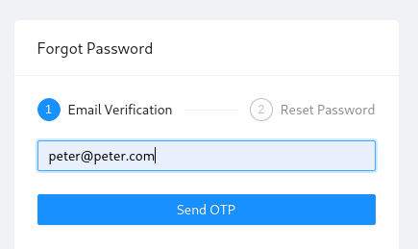

Enter the wrong otp

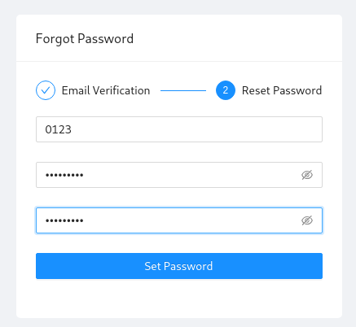

**and intercept this request**

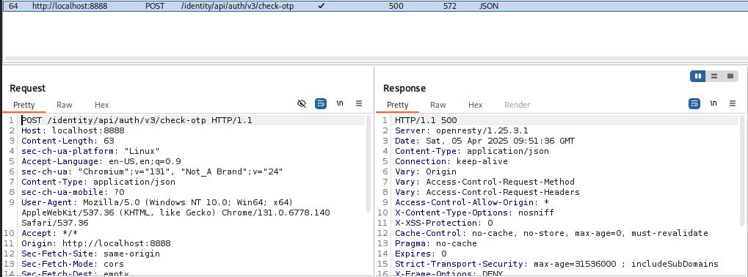

**And send to the intruder for otp bruteforce and set the payload**

**Attack type; sniper**

**Otp set ; 0000-9999**

**Start the attack**

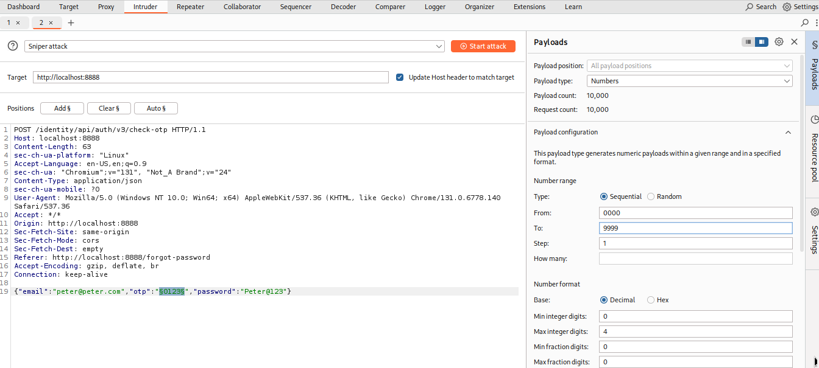

**One thing always remember every time when you start the attack uncheck the URL-encode**



Here my attack is fail because of this api using v3 this not vulnerable

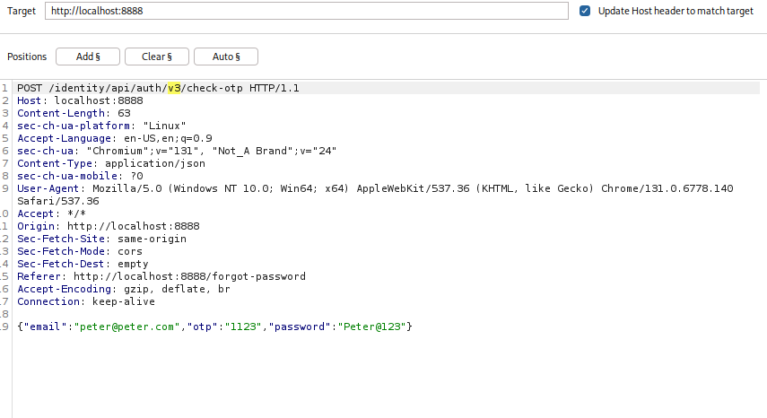

And intercept the request again and send to the intruder and change the version v3 to v2

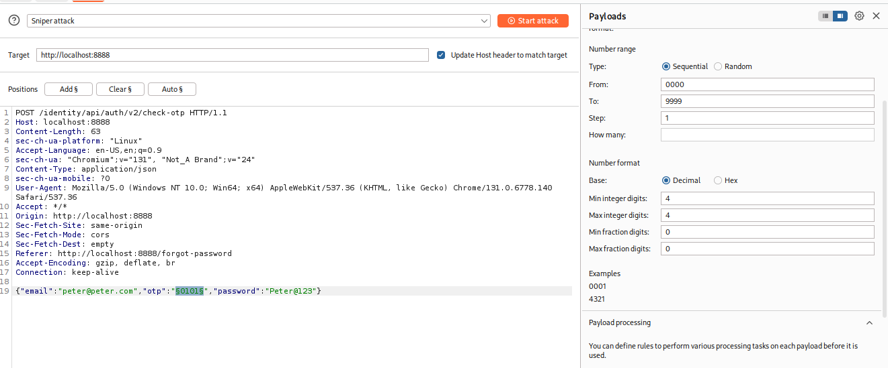

**Here is my attack is successful because of not rate limiting**

**Here allow attackers to bypass login**

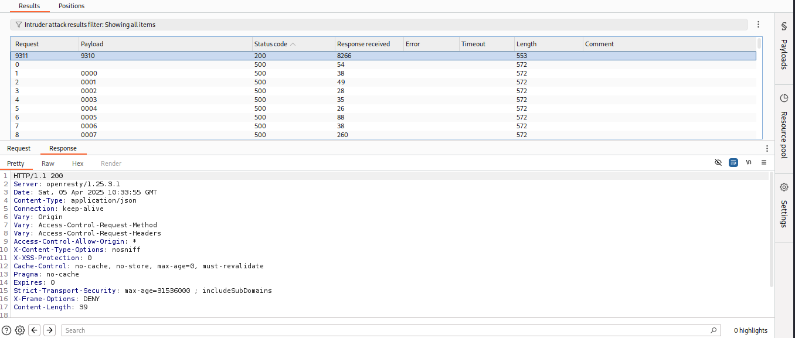

**Go the browser and enter the otp**

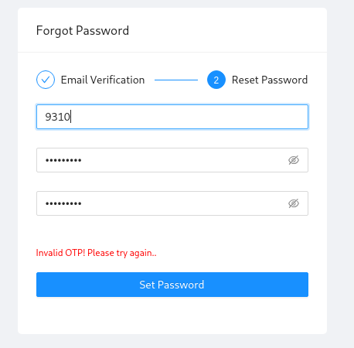

**Here You can bruteforce the otp with tool like hsfuzz and ffuf**

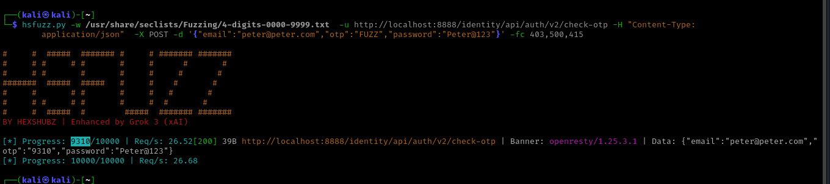

**API 03:2023 — Broken Object Property Level Authorization**

This category combines [API3:2019 Excessive Data Exposure](https://owasp.org/API-Security/editions/2019/en/0xa3-excessive-data-exposure/) and [API6:2019 - Mass Assignment](https://owasp.org/API-Security/editions/2019/en/0xa6-mass-assignment/), focusing on the root cause: the lack of or improper authorization validation at the object property level. This leads to information exposure or manipulation by unauthorized parties.

**Exploitation;**

**Go the /shop endpoint here present three products**

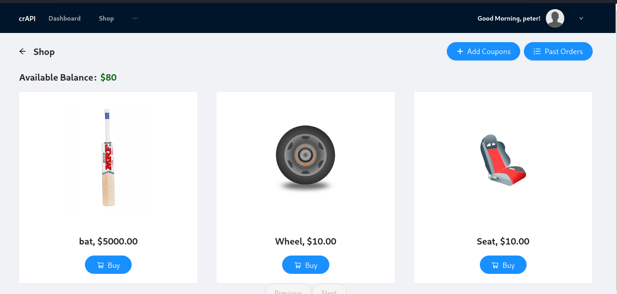

**Intercept this endpoint**

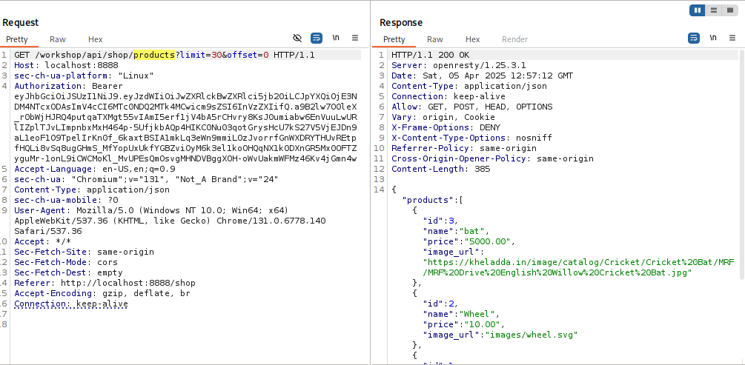

**And change this method to POST and come bad request but you can see this below this field is required**

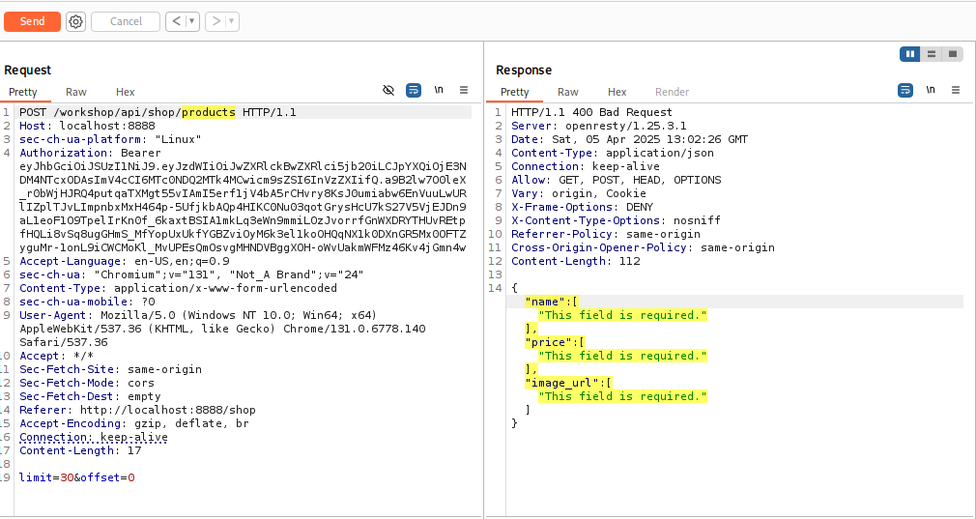

**And I fill-ups the required filled with Jason data send to the request and come 200 ok**

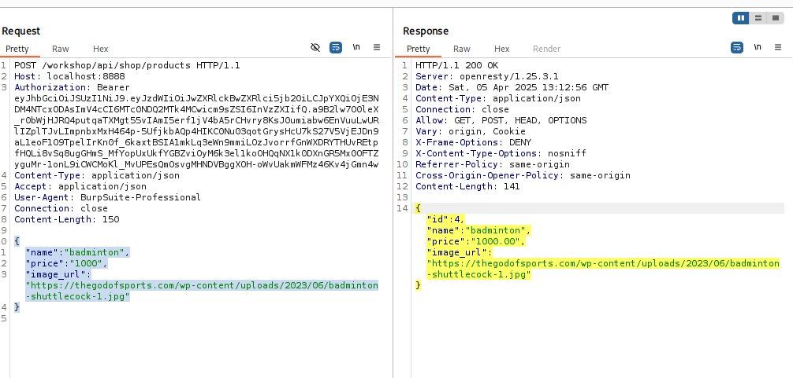

**Retrieve the data with GET method here you can see my item(badminton) is added**

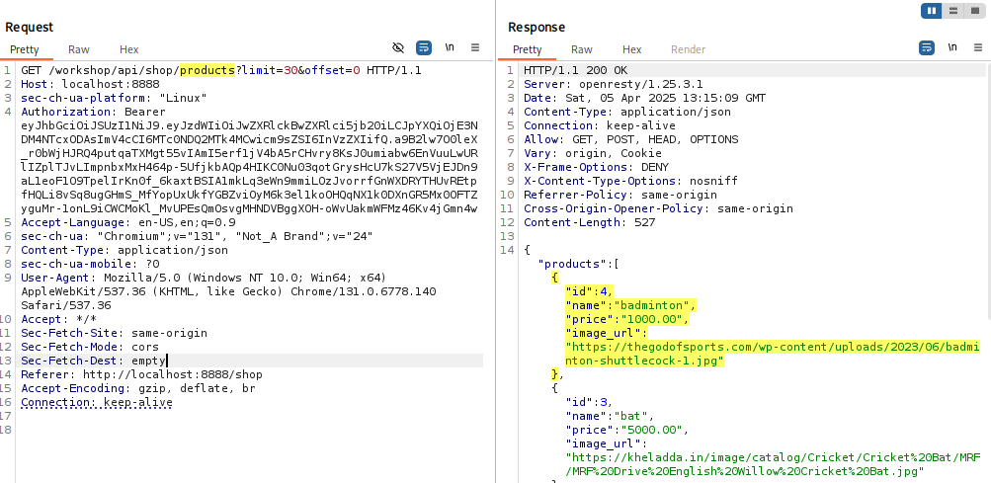

**Here You can see this item is successfully added on web application**

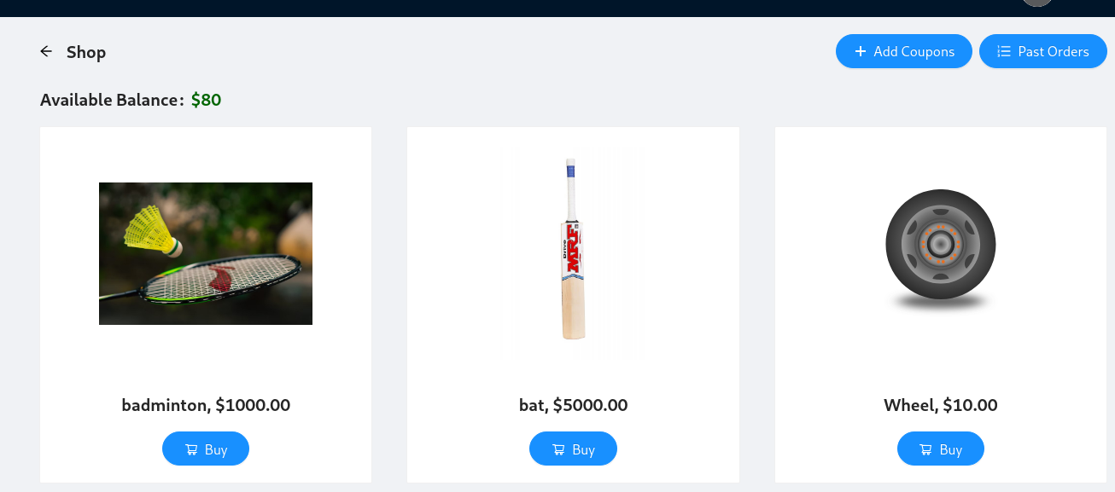

**🛑 API 04:2023 —** Unrestricted Resource Consumption

**🔍 Issue:**

Attackers abuse API requests to overload the system.

API has no rate limits on CPU, memory, or bandwidth usage**.**

**🔨 Exploitation ; go the the order page**

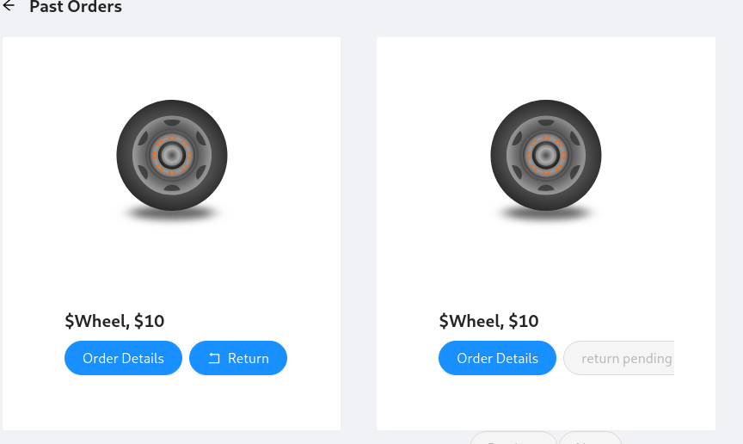

**Intercept the request of order**

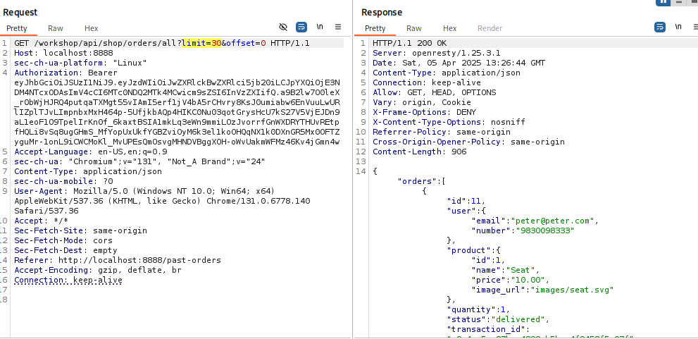

**I increase the large limit (1000000) but come same response**

**Hit this endpoint multiple times with high limits (e.g. Burp Intruder) to:**

**Cause DoS**

**Detect if there's rate limiting**

**Observe performance impact**

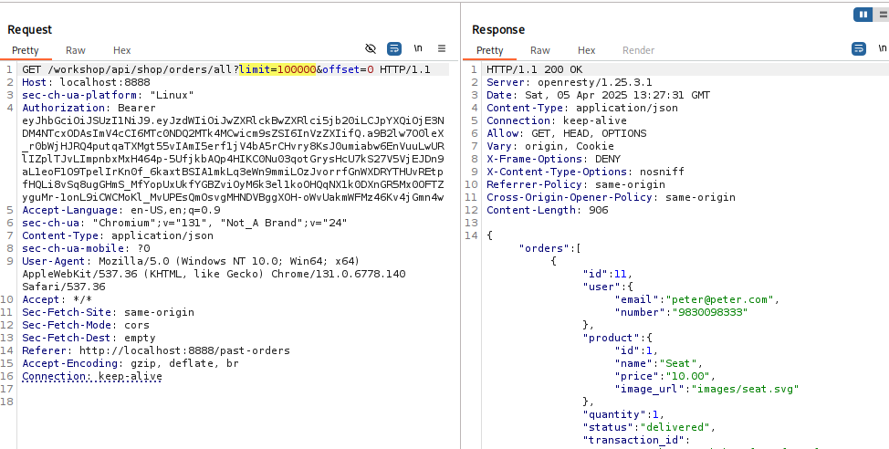

**🔒 Secure Fix (for devs):**

Server-side validation

**if limit > 100:**

return {"error": "Limit exceeds maximum allowed (100)"}, 400

🛑 **API 05:2023** — Broken Function Level Authorization

**🔍 Issue**:

Users can access admin functions due to poor role checks.

**🔨 Exploitation** :

Upload the video to click on three dot and change the name of video

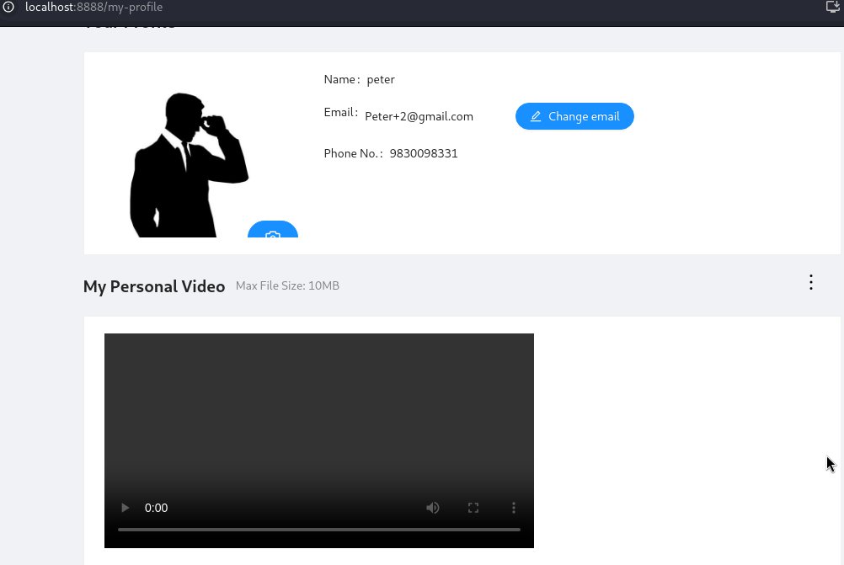

**Intercept the request**

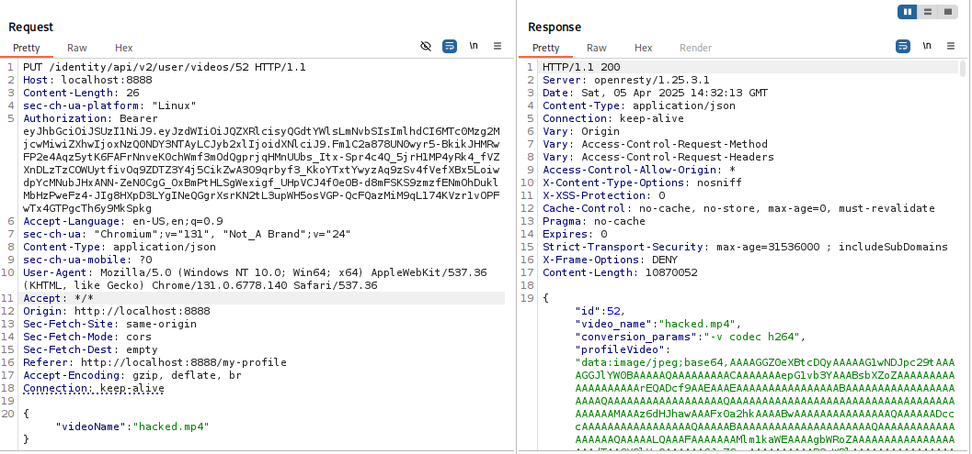

**Here I analyse the request using options methods to see which method is allow here.**

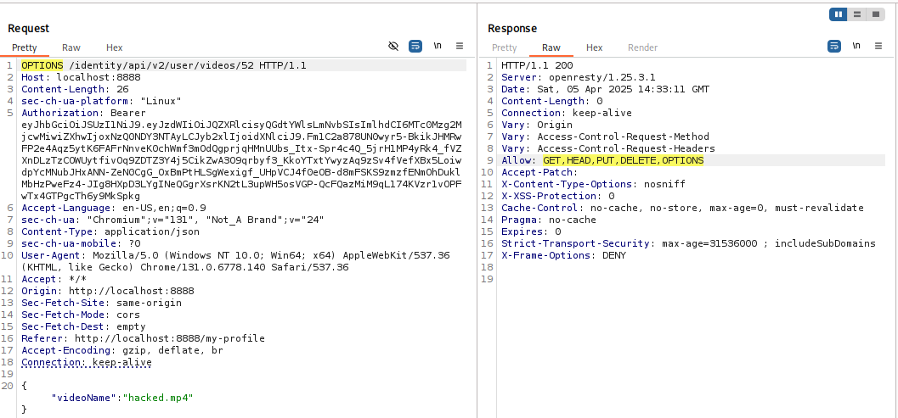

Here I choose DELETE method but come 404 and u read this message in request below

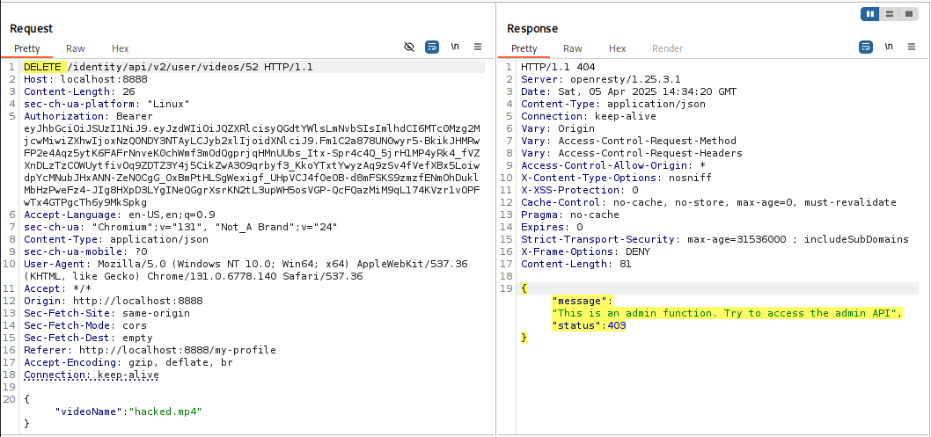

**Here I change user to admin and video deleted successfully and my attack is successful to BFLA vulnerability**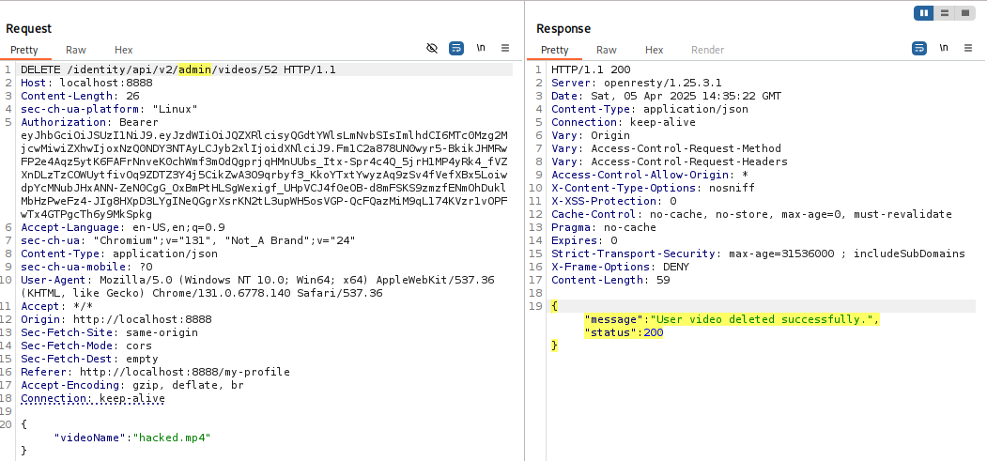

**🛑 API 06:2023 —** Unrestricted Access to Sensitive Business Flows

**🔍 Issue:**

APIs expose business-critical functions without restrictions.

Attackers abuse account creation, financial transactions, etc**.**

**🔨 Exploitation :**

**Now you're sending all required fields**, and the API accepts it:

* email: attacker{}@mail.com
* password: P@ssw0rd
* name: attacker{}
* number: 123456789{}

The backend API is built using **Spring Boot**, and it’s validating input with annotations like @NotBlank. That’s why you got errors like:

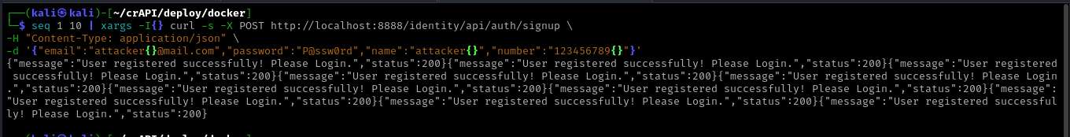

### ✅ Why is this a vulnerability?

1. **No rate-limiting / CAPTCHA**  
   ⇒ You can automate user signups without restriction
2. **No authentication needed to hit signup endpoint**  
   ⇒ Anyone can register **multiple fake users**, maybe to:
   * Spam the system
   * Fill up the database
   * Use those accounts to perform further attacks
3. **Critical business flow exposed without control**  
   ⇒ Account creation should have protections in place

### 💥 Vulnerability: Unrestricted Access to Sensitive Business Flows

This happens when:

* Business logic flows (like registration, password reset, checkout) are exposed without security measures
* There's no check for abuse

🛑 **API 07:2023** — Server-Side Request Forgery (SSRF)

🔍 **Issue:**

APIs allow users to request external/internal URLs.

Attackers force the server to fetch unauthorized data.

🔨 **Exploitation;**

Go the contact page

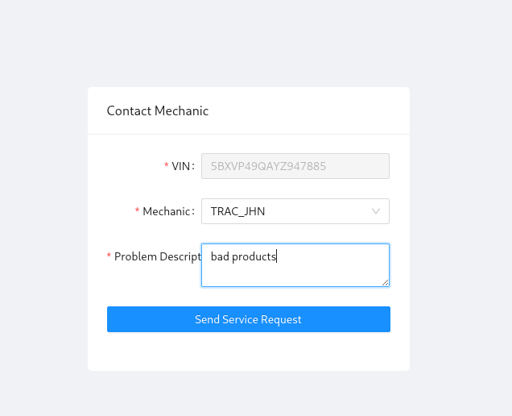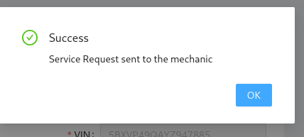

Intercept the request

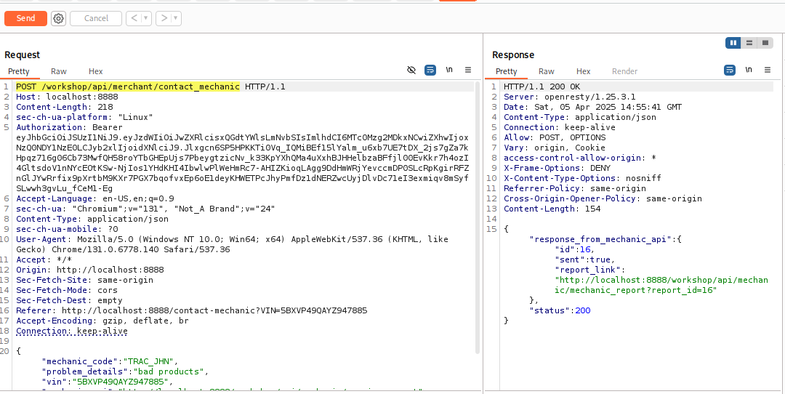

Here you can check the request data send to this type

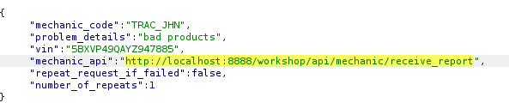

**Here I change the url highlighted in yellow colour and fetch of this url request this is vulnerable to ssrf**

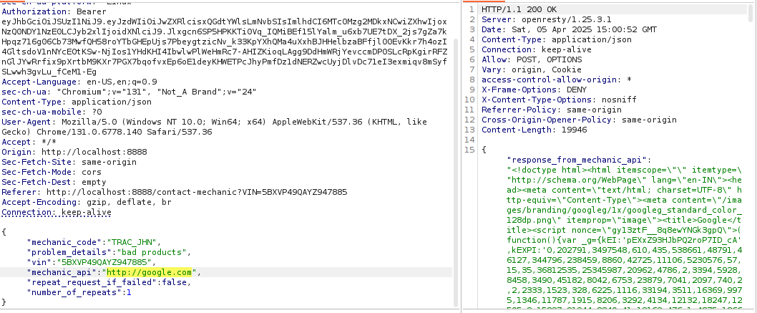

**SQLI Check there**

**Fetch this endpoint and intercept the burp and send to the repeater**

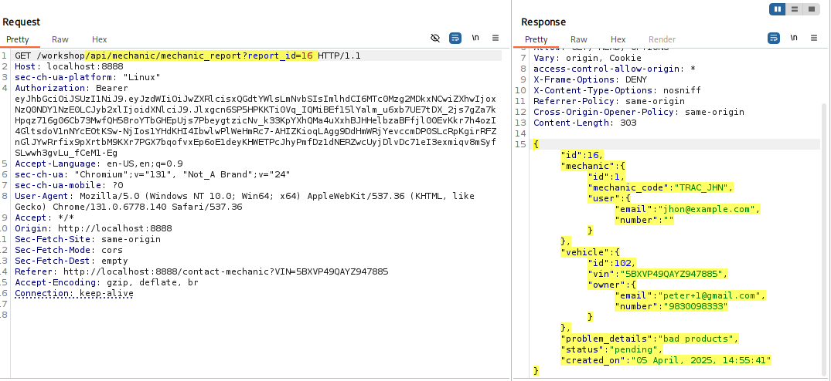

**I try here sqli and come error this is the first clue of error based sqli**

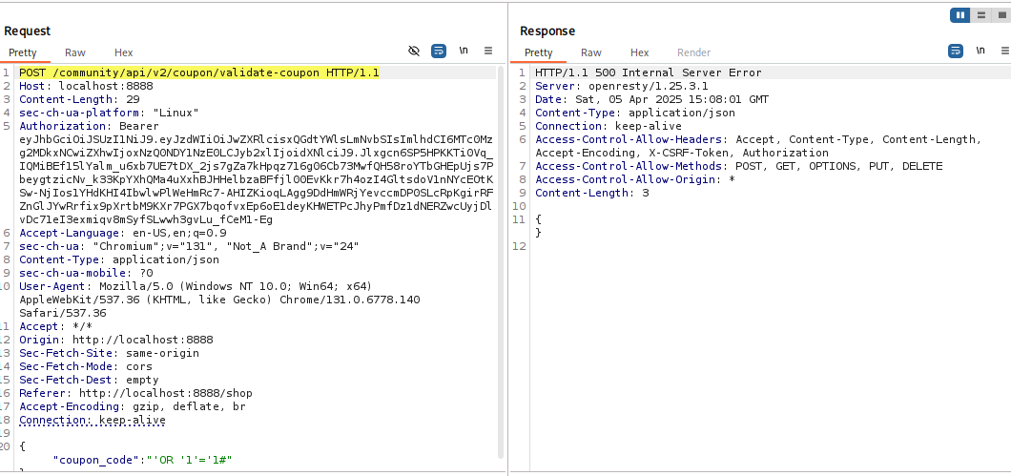

**Here I using no sql payload and this successful you can see this below**

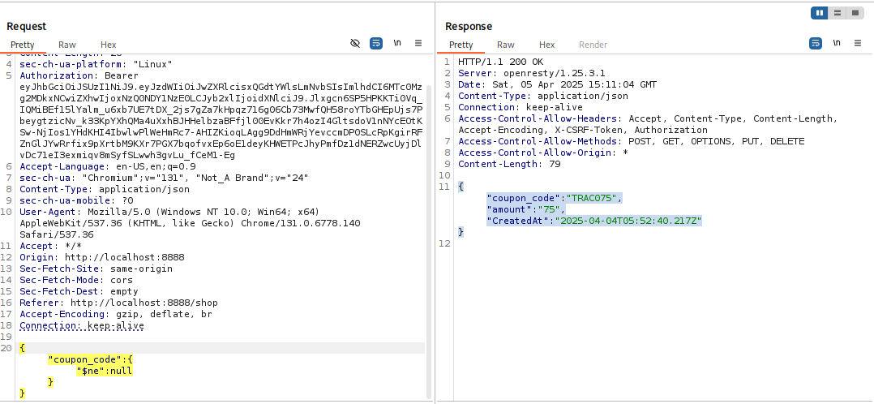

**Here I validate the coupon**

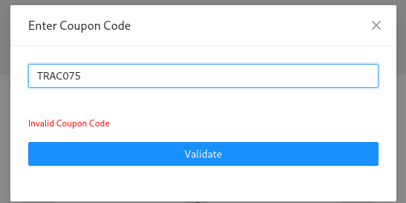

**Work this conform to sqli**

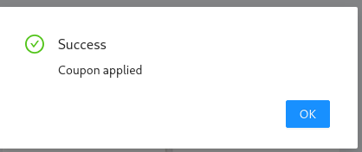

**Second example of sqli**

**Go to the /workshop/api/shop/apply_coupon endpoint try sql payload and come error again**

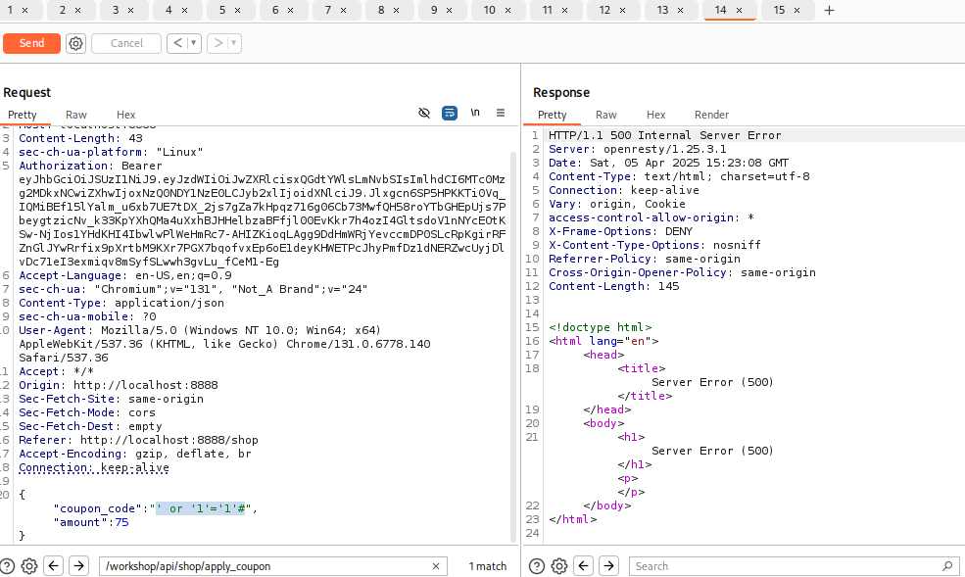

**Use this payload to see the version you can see this below**

**‘ ; select version ();--**

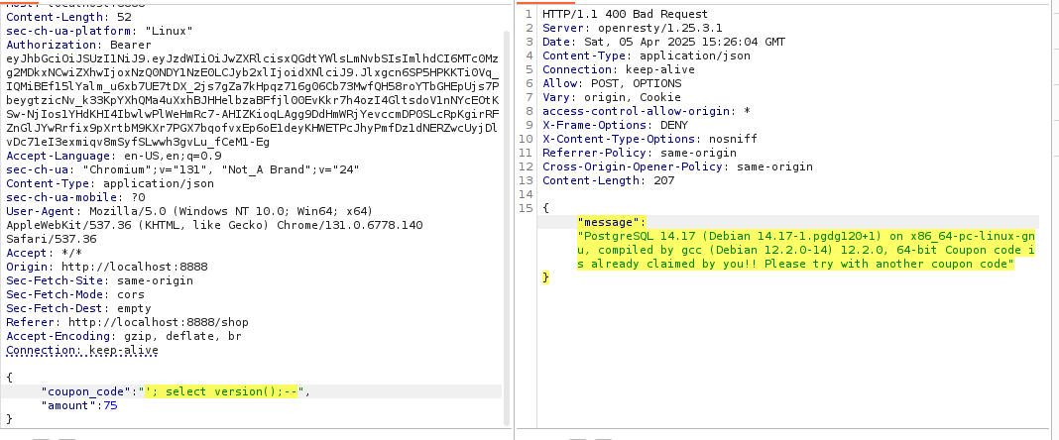

**See for data base use this payload**

**‘ ; select current_database ();--**

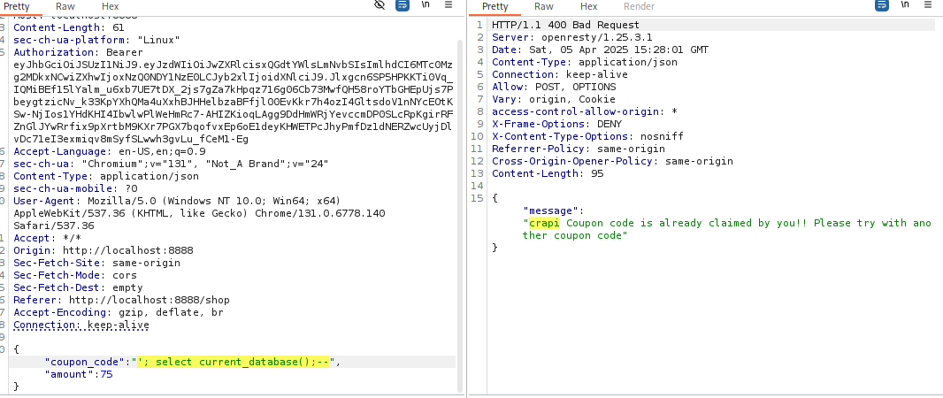

**🛑 API 08:2023 —** Security Misconfiguration

**🔍 Issue:**

API has default credentials, open admin panels, or unnecessary headers.

Attackers exploit misconfigurations to access sensitive info**.**

**🔨 Exploitation Example:**

**# Checking for open API docs & admin panels**

curl -X GET "https://api.example.com/admin"

curl -X GET "https://api.example.com/swagger"

**✅ Fix:**

Disable API documentation in production.

Enforce least privilege access to admin panels.

**🛑 API 09:2023** — Improper Inventory Management

**🔍 Issue:**

APIs expose deprecated/hidden endpoints attackers can abuse.

**🔨 Exploitation Example:**

# Fuzzing for hidden API endpoints

ffuf -w wordlist.txt -u https://api.example.com/FUZZ

**✅ Fix:**

Regularly audit APIs & remove outdated endpoints.

Implement strict API versioning.

**🛑 API 10:2023 —** Unsafe Consumption of APIs

**🔍 Issue:**

API blindly trusts data from third-party APIs.

Attackers inject malicious payloads via external API calls**.**

**🔨 Exploitation Example:**

# An API integrates with an external payment system

curl -X POST "https://api.example.com/payment" -d '{"amount":"100","status":"paid"}'

**✅ Fix:**

Validate & sanitize all third-party API responses.

Implement signature-based verification for external data.